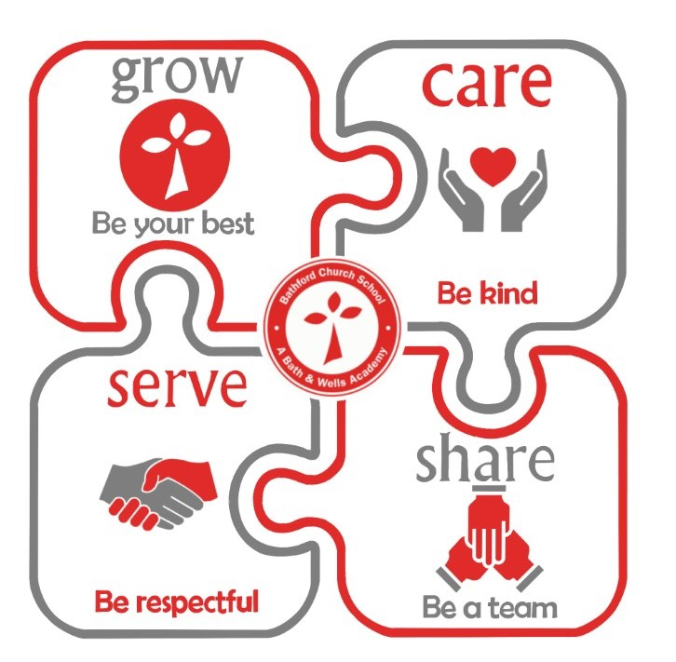

Bathford Church School
Early Years Policy
Our Early Years Vision Statement

This is a safe place for children to learn and grow; they are treasured and valued as individuals whose feelings, thoughts and beliefs are important and heard. The children in our care are all special and unique, this is shared and celebrated in our class. We encourage each other and kindness is at the forefront of all we do. Children learn how they can serve each other and the wider world through their respectful and thoughtful choices and actions. We instil positive learning behaviours by acknowledging every child’s efforts and achievements. Our curriculum sparks children’s curiosity and fosters a sense of awe and wonder. The teaching and provision evolves to reflect our children and their interests. We know children learn best through play, and therefore believe that direct teaching needs to be playful to reflect the joyful nature of learning. Our classroom is full of laughter and fun. We talk and share, we test and solve.
“Every child deserves the best possible start in life and the support that enables them to fulfil their potential. Children develop quickly in the early years and a child’s experiences between birth and age five have a major impact on their future life chances. A secure, safe, and happy childhood is important in its own right. Good parenting and high-quality early learning together provide the foundation children need to make the most of their abilities and talents as they grow up.”

Statutory Framework for the Early Years Foundation Stage.
Setting the standards of learning, development, and care for children from birth to five.
New Reform document, March 2021

The EYFS seeks to provide:
Quality and consistency in all early years settings, so that every child makes good progress and no child gets left behind

A secure foundation through planning for the learning and development of each individual child, and assessing and reviewing what they have learned regularly

Partnership working between practitioners and with parents and/or carers

Equality of opportunity and anti-discriminatory practice, ensuring that every child is included and supported

Our EYFS learning and development requirements cover:

The areas of learning and development, which must shape activities and experiences for children in all early years settings

The early learning goals (ELGs) that we must help children work towards (the knowledge, skills and understanding children should have at the end of the academic year in which they turn five)

Assessment arrangements for measuring progress, that requires us to report to parents and/or carers.

At Bathford Church School we refer to the Birth to Five Matters and Development Matters, both of which are non-statutory curriculum guidance for the EYFS. They are used as supporting materials for the planning and implementation of the EYFS learning. During planning we use a progression model where skills and knowledge are broken into small steps.

Overarching Principles of the EYFS

The Four guiding principles

The Unique Child
Every child is a unique child, who is constantly learning and can be resilient, capable, confident and self-assured

Positive Relationships
Children learn to be strong and independent through positive relationships

Enabling Environemnts & Supportive Adults
Children learn and develop well in enabling environments with teaching and support from adults, who respond to their individual interests and needs and help them to build their learning over time. Children benefit from a strong partnership between practitioners and parents and/or carers.

Learning and Development
Children develop and learn at different rates. (See “the characteristics of effective teaching and learning” at paragraph 1.15). The framework covers the education and care of all children in early years provision, including children with special educational needs and disabilities (SEND).

Objectives
• To provide a nurturing, joyful and safe setting for learning which meets all children’s needs and interests in our care.
• To deliver an exiting environment which enables children to learn and includes a range of continuous and linked provision activities with rich and challenging opportunities
• Encourage caring and secure professional relationships between children and adults, based on a mutual respect and acknowledgment of the feelings of children and their families.
• Strong, warm and supportive relationships are nurtured and crucial to how the children learn and understand their own feelings and those of others.
• To ensure high quality interactions between adults and children provide a language-rich environment, where opportunities to use and embed new language and vocabulary is actively sought.
• A curriculum that is broad and inspiring so that all children with the best possible chance to achieve and enjoy all areas of learning and development.
• To embed our school values so that children become aware of moral and social values and develop a deep sense of care and kindness for each other and the world around them.
• To encourage active learning through play both in indoors and outdoors.
• To encourage children to become engaged, self-motivated and independent learners with a positive attitude to learning and their own capabilities.
• To ensure that physical activity is provided throughout each day, so that children gain an all-round development, enabling them to pursue happy, healthy and active lives.
• To value cultural diversity and provide opportunities for the children to make sense of their physical world and community.
• To foster positive relationships with parents and carers and to share the common purpose of providing best possible care and education for child.

The Areas of Learning and Development
There are seven areas of learning and development: 3 Prime Areas and 4 Specific Areas.

All areas are important and inter-connected:
Prime Areas
Three areas are particularly important for building a foundation for igniting children’s curiosity and enthusiasm for learning, forming relationships and thriving.

• Personal, Social and Emotional Development
• Communication and Language
• Physical Development

Specific Areas
These four specific areas, through which the three prime areas are strengthened and applied.

• Literacy
• Mathematics
• Understanding the World
• Expressive Arts and Design

Characteristics of Effective Learning

At Bathford Church School we believe that the COEL are key to developing children’s well being and positive learning behaviours. Embedding these principles helps us to enable children to become life-long learners. In planning and guiding what children learn practitioners must reflect on the different rates at which children are developing and adjust their practice appropriately.

Three characteristics of effective teaching and learning are:
• Playing and exploring – children investigate and experience things and ‘have a go’.
• Active learning – children concentrate and keep on trying if they encounter difficulties and enjoy achievements.
• Creating and thinking critically – children have and develop their own ideas, make links between ideas, and develop strategies for doing things.

Parents as Partners

At Bathford Church school we appreciate the role that parents have played, and their future role, in educating their children. We highly value the contribution they make to us as a school community. Our induction program ensures that there are plenty of opportunities for parents to meet us and establish positive relationships. Communication is key to our partnership with parents so weekly information sharing, newsletters, parent meetings, and our sharing of children’s learning journals ensure positive relationships between school, child, and parent.

Assessment
The Statutory Framework calls for two levels of assessment in the EYFS. Formative assessments involve noticing what the children do and say through observations. The teacher will assess and decide ‘what next’ in terms of planning, organization, resources, learning environment and opportunities. Our children’s progress and attainment is carefully observed and included in learning journals for evidence.

The level of development children should be expected to have attained by the end of the EYFS is defined by the Early Learning Goals (ELG’s). The ELG’s support teachers to make a holistic, best-fit judgment about a child’s development in readiness for Year 1. We base these judgments using a range of evidence but mainly we draw upon our extensive knowledge of each child.
Below are the 17 ELG’s across each area of learning and development:

Communication and Language
• Listening, Attention and Understanding
• Speaking

Personal, Social and Emotional Development
• Self-Regulation
• Managing Self
• Building Relationships

Physical Development
• Gross Motor Skills
• Fine Motor Skills

Literacy
• Comprehension
• Word Reading
• Writing

Mathematics
• Number
• Numerical Patterns

Understanding the World
• Past and Present
• People, Culture and Communities
• The Natural World

Expressive Arts and Design
• Creating with Materials
• Being Imaginative and Expressive

Each child’s progress and achievements will be reported to parents during parent meetings. Your child’s end of year attainment will be presented in the end of year reports, included in this report will be the three key characteristics of effective learning.

Induction

We invite our parents in to have a tour of the school and meet the EYFS team prior to induction.
Formal Induction begins with a parent & child meeting in June where parents are invited to meet the teacher, head teacher and teaching assistants. This is an opportunity to learn more about our school routines and what a day in the life of a reception child looks like. During this meeting, the children are invited to play in our outdoor area and to familiarise themselves with their peers, the environment and supporting adults. The teacher will contact all nurseries/preschools to discuss children entering our settling and may also visit settings in the summer term to meet children. The children will also attend school for a morning story time in the classroom with their new teacher and supporting adults.

Induction in the first term consists of the children attending school part-time for the initial first 3 weeks. The children spend mornings at school for the first week and ½ , they then spend the remaining week and ½ staying for lunch. This gradual approach to the start of their schooling enables the teacher and pupils to get to know each other and build up to full-time days.

Home visits

During the initial part-time induction, the class teacher and teaching assistant will visit each child at their home in the afternoons. We allow 30/40minutes for these home visits. The visits are a wonderful and memorable experience for the children and help the children to feel comfortable and to get to know us in their own space and to share what is important to them. The teacher will use this opportunity to talk to the parents about key aspects of the Reception curriculum, including the phonics programme.

Transition from Reception to Year 1

We want to ensure a smooth and successful transition from the Early Years Foundation stage setting to Year l.

This is assisted by:
• The Year 1 teacher covering PPA time in Reception Class each week
• Reception class will also spend the whole morning in their new classroom and with their new teachers and support staff.
• SEN children - liaison with parents, outside agencies and teachers with regards to any special arrangements or adjustments will be made during the transition period.
• Reception teacher and Year 1 teachers will meet before the new term in September to discuss the class and pass on all profile reports and discuss each child’s skills and abilities in relation to curriculum and the three key characteristics of effective learning.
• Reception teacher and Year 1 teachers will discuss transition during the first term. Support will be given for any children who are still working within the EYFS.
• Parents will meet the new Year 1 teachers during ‘Meet the Teacher’ morning in September.

Role of the Foundation Stage Teacher

It is the role of the Foundation teacher, under the guidance of the Head Teacher: -
• To organise the delivery of EYFS Curriculum and to ensure progression and development.
• To monitor planning and quality of delivery within the curriculum.
• To set targets and track progress termly, including children within vulnerable groups i.e., Pupil Premium.
• Use formative and summative assessments to inform final EYFS profile judgements.
• To send profile data to the LA and MAT on time and complete.
• To keep abreast of developments within Early Years through on-going CPD opportunities.
• To take part in yearly moderation, supported by the BANE’s Early Years Team.
• To attend EYFS Bath Hub cluster meetings and to take part in triad with 2 other schools.
• To ensure close links with parents and carers.

Equal Opportunities
All children have an equal entitlement to a good Early Years Curriculum regardless of gender, race, culture, Religion, disability and special or medical needs.

Safeguarding
All staff to attend yearly Safeguarding training and are kept up to date with new legislations. It is important to us that all children in school are ‘safe’ and feel safe. We aim to educate children on boundaries, rules, and limits to help them understand why they exist. We provide children with choices to help them develop this important life skill. Children should be allowed to take risks but need to be taught how to recognise and harmful risks. We aim to protect the physical and psychological well-being of all children. The teacher and teaching assistants are First Aid trained and hold certificates. Training and certificates are are updated every three years.

Policy set: Sept 2022
Review: Sept 2023

