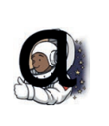 | 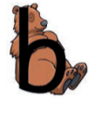 | 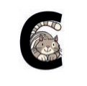 | 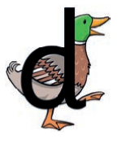 | 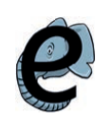 | 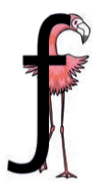 | 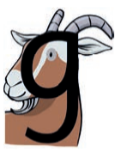
Around the astronaut’s helmet and down into space. | Down bear’s back, up and round his big tummy. | Curl around the cat. | Round the duck’s body, up to its head and down to its feet. | Around the elephant’s eye and down its trunk. | Down the flamingo’s neck, all the way to its foot, then across its wings. | Round the goat’s face, up to his ear; down and curl under his chin.
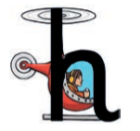 | 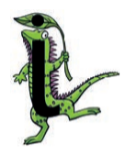 | 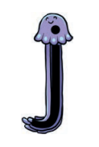 | 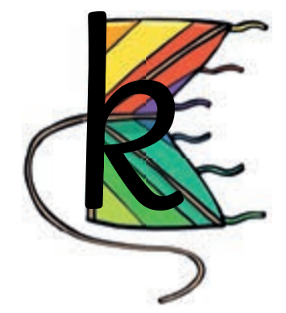 | 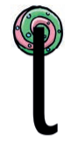 | 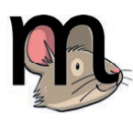 | 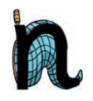
Down, up and over the helicopter. | Down the iguana’s body, then draw a dot (on the leaf) at the top. | All the way down the jellyfish. Dot on its head. | Down the kite, up and round, down to the corner. | All the way down the lollipop. | Down, up and over the mouse’s ears, then add a flick on the nose. | Down the stick, up and over the net.
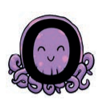 | 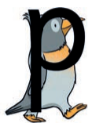 | 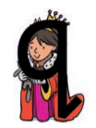 | 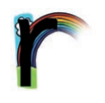 | 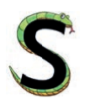 | 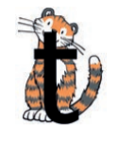 | 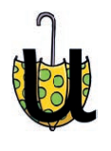
All around the octopus | Down the penguin’s back, up and around its head. | Round the queen’s face, up to her crown, down her robe with a flick at the end. qu Quick, it’s the queen! | From the cloud to the ground, up the arch and over the rainbow. | Under the snake’s chin, slide down and round its tail. | From the tiger’s nose to its tail, then follow the stripe across the tiger. | Down and around the umbrella, stop at the top and down to the bottom and flick.
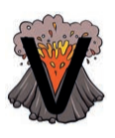 | 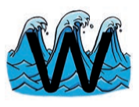 | 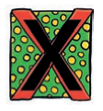 | 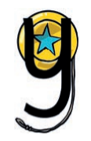 | 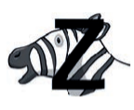
Down to the bottom of the volcano and back up to the top. | From the top of the wave to the bottom, up the wave, down the wave, then up again. | Start at the top, then across to the bottom of the box. Start at the top, then across to the bottom of the box. | Down and round the yo-yo, then follow the string round. | Zip across, zag down and across the zebra.

