Relationships, Sex and Health Education policy (from 2020)
Bathford Church School

Approved by: | [Name] | Date: [Date]
Last reviewed on: | [Date]
Next review due by: | [Date]

Contents
1. Aims and Objectives 2
2. Statutory requirements 3
3. Policy development 3
4. Definition 3
5. Curriculum 3
6. Delivery of RSHE 4
7. Roles and responsibilities 6
8. Parents’ right to withdraw 7
9. Training 7
10. Monitoring arrangements 7
Appendix 1: Curriculum map 8
Appendix 2: By the end of primary school pupils should know 9
Appendix 3: Parent form: withdrawal from sex education within RSHE 14

Aims and Objectives
The aims of Relationships, Sex and Health (RSHE) Education at our school are to:
- Provide an age appropriate framework in which sensitive discussions can take place.
- Help pupils develop feelings of self-respect, confidence and empathy.
- Help pupils to form healthy, positive relationships and respect for others.
- Help pupils to be responsible global citizens, understanding their responsibilities within relationships.
- To prepare pupils for the physical and emotional challenges of growing up- preparing for puberty, and giving them an understanding of the importance of health and hygiene.
- To understand how to stay healthy, both physically and mentally.
- To be able to recognize safe and unsafe situations, communicating effectively.

Through a planned programme of learning, we aim to provide our pupils with the knowledge, understanding and skills that they need in order to manage their lives now and in the future. Our Christian vision of Grow (be your best), Care (be kind), Serve (be respectful) and Share (be a team) informs our teaching of the Relationships, Sex and Health Education curriculum by developing the attributes our pupils need to thrive as individuals, as part of a family and part of the wider community. Our school is an inclusive and welcoming space where children are encouraged to be global citizens who develop strong relationships and have respect for themselves and others.

2. Statutory requirements
As a primary academy school we must provide relationships education to all pupils as per section 34 of the Children and Social work act 2017.
We do not have to follow the National Curriculum but we are expected to offer all pupils a curriculum that is similar to the National Curriculum including requirements to teach science which would include the elements of sex education contained in the science curriculum.
In teaching RSHE, we are required by our funding agreements to have regard to guidance issued by the secretary of state as outlined in section 403 of the Education Act 1996.
At Bathford Church School we teach RSHE as set out in this policy.

3. Policy development
This policy has been developed in consultation with staff, pupils and parents. The consultation and policy development process involved the following steps:
- Review – a member of staff or working group pulled together all relevant information including relevant national and local guidance
- Staff consultation – all school staff were given the opportunity to look at the policy and make recommendations
- Governor consultation- the policy was shared with governors from the School Improvement and Curriculum Development committee.
- Parent/stakeholder consultation – parents and any interested parties were invited to watch a virtual presentation about the policy and feedback to the school.
- Pupil consultation – we investigated what exactly pupils want from their RSHE
- Ratification – once amendments were made, the policy was shared with governors and ratified.

4. Definition
RSHE is about the emotional, social, cultural and physical development of pupils, and involves learning about relationships, sexual health, healthy lifestyles, diversity and personal identity.
RSHE involves a combination of sharing information, and exploring issues and values.
Is it about equipping children and young people with the information, skills and values to have safe, fulfilling and enjoyable relationships and to take responsibility for their sexual health and well-being.
RSHE is not about the promotion of sexual activity.

5. Curriculum
Our RSHE curriculum is embedded in our PSHE curriculum across all year groups. We undertake to follow the principles in the Church of England Charter for faith sensitive and inclusive relationships education, relationships, sex and health education (RSHE) and the legal requirements of the National Curriculum for Science, which state that children at Key Stage 2 be taught the main stages of the human life cycle, “Pupils should be taught to describe the changes as humans develop to old age.” The curriculum is set out using one theme each term as shown below but may be adapted as and when necessary, in order to best meet the needs of the children in our care, with some curriculum content being undertaken incidentally as issues arise from daily events.

Term 1 – Healthy and happy friendships
Term 2 – Similarities and differences
Term 3 – Caring and responsibility
Term 4 – Families and committed relationships
Term 5 – Healthy body, healthy mind
Term 6 – Coping with change
In particular, Relationships Education focuses on teaching the fundamental building blocks and characteristics of positive relationships including:
- Families and people who care for me
- Caring friendships
- Respectful relationships
- Online relationships
- Being safe

Primary Sex Education will focus on:
- Preparing boys and girls for the changes that adolescence brings.
- Understanding how a baby is conceived and born, considering the context of relationships.
For more information about the year group curriculum content, see our curriculum map in Appendix 1.

The curriculum is relevant to children living in today’s world as it helps them to navigate areas such as: friendship, online safety and caring for our community. The Relationships Education and curriculum supports the teaching of the Sex Education content in Years 5 and 6, by sharing the value of a loving, stable relationship. Pupils are given the opportunity to develop their own attitudes, values and beliefs and to develop an individual moral code that will guide their actions, this is exercised within an understanding of the right of people to hold their own views within a framework of respect for others. While we use Relationships and Sex Education to inform children about sexual issues, we do this with regard to matters of morality and individual responsibility, and in a way that allows children to ask and explore moral questions. We do not use relationships and sex education as a means of promoting any form of sexual orientation. We teach relationships and sex education having due regard for the age of children that are taught in primary school, building healthy attitudes and positive relationships in an environment where difference is celebrated, and everyone is included and valued for who they are. Our RSHE provision is developmental and provides a foundation for further learning in secondary schools.

Delivery of RSHE
The school uses the ‘Discovery Education and Health Education’ programme. This is a comprehensive scheme of work using a fully resourced, age appropriate, PSHE programme, which covers the complete statutory Relationships Education and Health Education requirements for Primary Schools. Discovery Education brings together PSHE and RSHE learning through six termly overarching topics that allow children to explore their own values and identity whilst developing understanding and respect for the world and people around them. The programme is designed as a whole school approach, with all year groups working on the same theme at the same time. The six themes are designed to progress in sequence from September to July across the school, with each year group exploring a different area of focus through age-appropriate adaptations and materials. The topic themes have been developed in a spiral curriculum so that children can build on their skills and understanding each year.
The curriculum takes into account the age, needs and feelings of pupils whilst being sensitive to the faith and beliefs of those in the wider school community. If pupils ask questions outside the scope of this policy, teachers will respond in an age-appropriate manner so they are fully informed and don’t seek answers online.
In line with our whole school curriculum key principles, we use a variety of strategies to ensure that learning is purposeful, active and exciting, making links to our overarching whole school themes ‘Identity and Diversity, Social Justice and Equity and Sustainable Development’ when appropriate. A range of teaching methods are used to involve children’s full participation during RSHE sessions, including: videos, discussion, case studies, drama and creative opportunities. Our class teachers deliver the class lessons and establish clear ground rules before each session, encourage questions and promote ‘distance learning’ when appropriate so that children can think objectively.
Establishing a safe, open and positive learning environment based on trusting relationships between all members of the class, adults and children alike, is vital to successful and effective teaching and learning within this subject. The ground rules that are established by each class will be based on the following:
- We take turns to speak
- We use kind and positive words
- We listen to each other
- We have the right to pass
- We only use names when giving compliments or being positive
The RSHE curriculum is supported by other subjects such as, Science, Physical Education and Religious Education, which contribute significantly to a child’s knowledge and understanding of their own body, family relationships, traditions such as birth and marriage and the emotions involved. Since RSHE incorporates the development of self-esteem and relationships, pupils’ learning does not just take place through the taught curriculum but also through all aspects of school life including in the playground and through their roles and responsibilities in our school community based on our whole school vision and behaviour expectations.
RSHE teaching and resources will be differentiated for children with special educational needs and disabilities (SEND) when appropriate and remain inclusive for all children. We recognise the potential vulnerabilities of children with SEND and their right to high quality RSHE. Our teaching and resources are inclusive of all pupils and families including those protected characteristics in the Equality Act. These areas of learning are taught within the context of family life, taking care to ensure that there is no stigmatisation of children based on their home circumstances (families can include single parent families, LGBT parents, families headed by grandparents, adoptive parents, foster parents/carers amongst other structures) along with reflecting sensitively that some children may have a different structure of support around them (for example: looked after children or young carers).

7. Roles and responsibilities
7.1 The governing body
The governing body will approve the RSHE policy and hold the headteacher to account for its implementation.
7.2 The headteacher
The headteacher is responsible for ensuring that RSHE is taught consistently across the school, and for managing requests to withdraw pupils from non-statutory components of RSHE (see section 8).
7.3 Staff
Staff are responsible for:
- Delivering RSHE in a sensitive way
- Modelling positive attitudes to RSHE
- Monitoring progress
- Responding to the needs of individual pupils
- Responding appropriately to pupils whose parents wish them to be withdrawn from the non-statutory components of RSHE
Teachers will reply to, and answer, children’s questions sensitively, openly and within a general context. They will ensure balanced information is provided which will take into account different faith’s views and opposing views.
Questions that staff feel uncertain about answering should be discussed with a member of the senior leadership team and answered at a later date.
7.4 Pupils
Pupils are expected to engage fully in RSHE and, when discussing issues related to RSHE, treat others with respect and sensitivity.
7.5 Parents
The school is aware that the primary role of RSHE lies with parents and carers. We wish to build a positive and supporting relationship with the parents of children at our school through mutual understanding, trust and co-operation. In promoting this objective, we:
- Inform parents about the school’s policy and practice, including sending a letter or email before beginning to teach any sex education units.
- Answer any questions parents may have about the RSHE of their child; this includes providing opportunities for parents to view examples of the resources used in lessons.
- Parents have the right to withdraw children from the non-statutory components of Sex Education within the RSHE.

8. Parents’ right to withdraw
Parents do not have the right to withdraw their children from Relationships Education.
Parents have the right to withdraw their children from the non-statutory/non-science components of Sex Education within RSHE – these have been highlighted in red on the curriculum map Appendix 1.
Those parents/carers wishing to exercise this right are invited to see the headteacher and or RSHE lead who will explore any concerns and discuss any impact that withdrawal may have on the child. Requests for withdrawal should be put in writing using the form found in Appendix 3 of this policy and addressed to the headteacher.
Alternative work will be given to pupils who are withdrawn from Sex Education.

9. Training
Staff are trained on the delivery of RSHE as part of their induction and it is included in our continuing professional development calendar.
The headteacher will also invite visitors from outside the school, such as school nurses or sexual health professionals, to provide support and training to staff teaching RSHE.

10. Monitoring arrangements
The delivery of RSHE is monitored by the senior leadership team (SLT) through, for example, learning walks, lesson observations, pupil voice, staff feedback and assessment monitoring.
Pupils’ development in RSHE is monitored by class teachers as part of our internal assessment systems.
This policy will be reviewed by SLT annually. At every review, the policy will be approved by the governors’ ‘School Improvement and Curriculum Development Committee’ and headteacher.

11. Linked Policies
- Behaviour policy
- Safeguarding and child protection policy
- The Equality Policy
- Anti-bullying policy
- Mental health and wellbeing policy
- Online safety policy
- RE Policy
- SEND Policy
- Teaching and Learning Policy

Appendix 1: Curriculum map
Relationships and sex education curriculum map
Year group | Healthy and happy friendships  Term 1 | similarities and differences  Term 2 | caring and responsibility  Term 3 | families and commited relationships  Term 4 | healthy body, healthy mind  Term 5 | coping with change  Term 6
Year 1 | Forming friendships and how kind and unkind behaviours impact others | Similarities and differences between people and how to respect and celebrate these. | Identify who our special people are and how they keep us safe. | What family is (including difference and diversity between families), and why families are important and special. | Our bodies and the amazing things we can do. Learning the correct names for the different body parts. | Growing from young to old and how we have changed since we were born.
Year 2 | Understanding what makes a happy friendship. Recognising personal boundaries and safe/unsafe situations. | Exploring different strengths and abilities. Understanding and challenging stereotypes. | The different communities and groups we belong to and how we help and support one another within these. | The different people in our families and how families vary. | Ways to stay healthy, including safe and unsafe use of household products and medicines. | Exploring how our bodies and needs change as we grow older. Aspirations and goal setting.
Year 3 | Being a good friend and respecting personal space. Strategies for resilience. | Respecting and valuing differences. Shared values of communities. | Our responsibilities and ways we can care and show respect to others. | Different types of committed relationships and the basic characteristics of these. | Maintaining physical and mental wellbeing, through healthy eating, sleep and keeping clean. | Coping with feelings around the changes in our lives.
Year 4 | Solving friendship difficulties. How to act if someone invades your privacy or personal boundaries. | Identity and diversity. Seeing different perspectives and not making judgements based on appearance. | Right and responsibilities within families and wider society, including the UN convention on the Rights of the Child. | The range of relationships we experience in our everyday lives. How we understand the differences between the types of relationships we encounter. | Influences on our health and wellbeing, including friends, family and media, and awareness of how these can affect personal health choices. | Coping with changes in friendships (alternative resources used).
Year 5 | Identity and peer pressure off and online. Positive emotional health and wellbeing. | Celebrating strengths. Setting goals and keeping ourselves safe online. | How our care needs change and effects of loneliness and isolation. Ways in which we can show care in the community. | The characteristics of healthy, positive and committed relationships and how these develop as we grow older. | Our unique bodies and self-acceptance – valuing our bodies and minds; lifestyle habits (including alcohol, tobacco and drugs) and their effect on wellbeing. | Sex Education: How bodies change as we enter puberty, including hygiene and menstruation.  How puberty changes our emotions and ways to manage this.
Year 6 | How relationships evolve as we grow, including when transitioning to secondary school. How to cope with a wider range of emotions. | Identity and behaviour online and offline. Reflecting on how people feel when they don’t ‘fit in’. | How we can take more responsibility for self-care and who cares for us as we grow older, including at secondary school. | Sex Education: adult relationships and human reproduction, including different ways to start a family. | Being the healthiest me: ongoing self-care of bodies and minds, including ways to prevent and manage mental ill health. | Ways to manage the increasing responsibilities and emotional effects of life changes.

Happy and Healthy Friendships
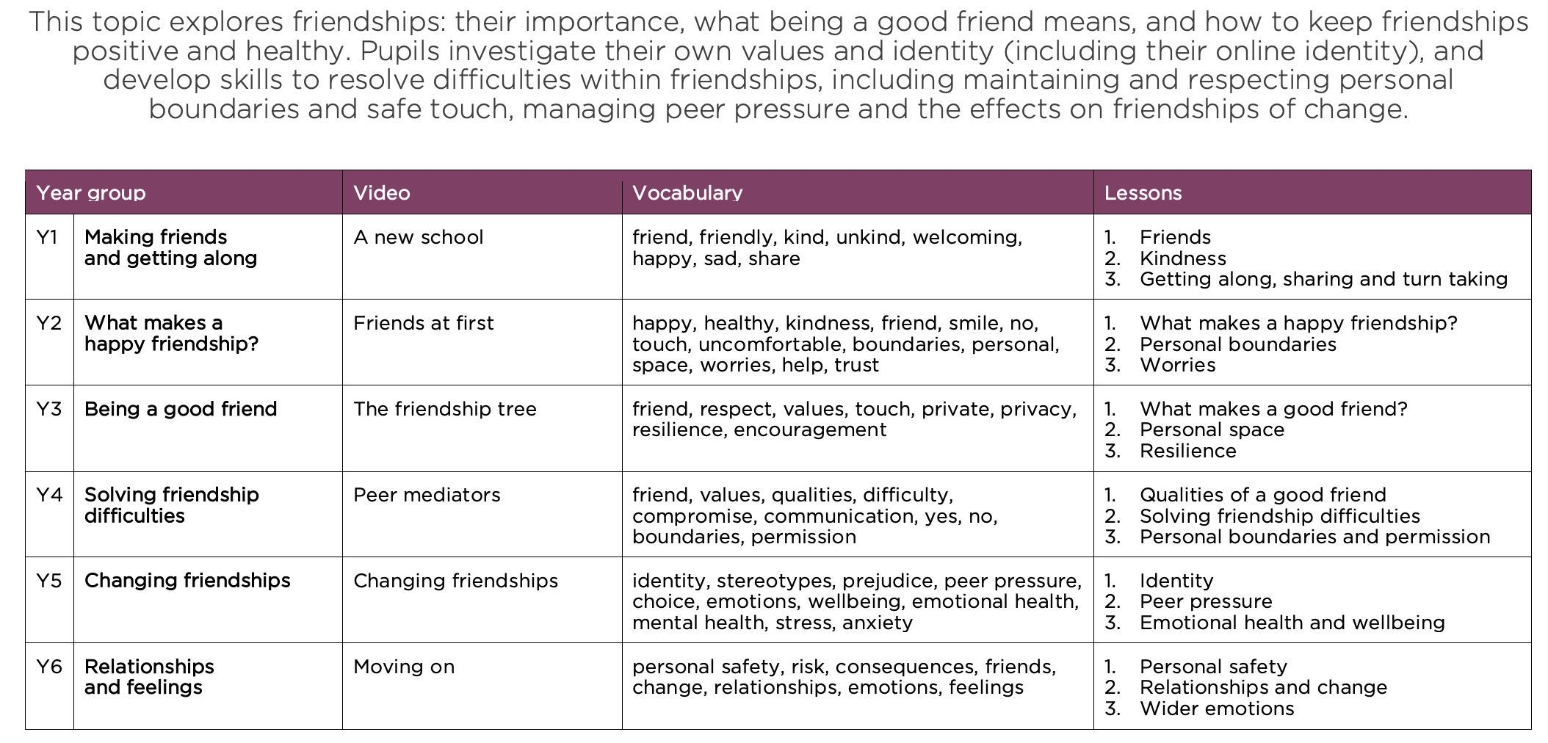

Similarities and Differences
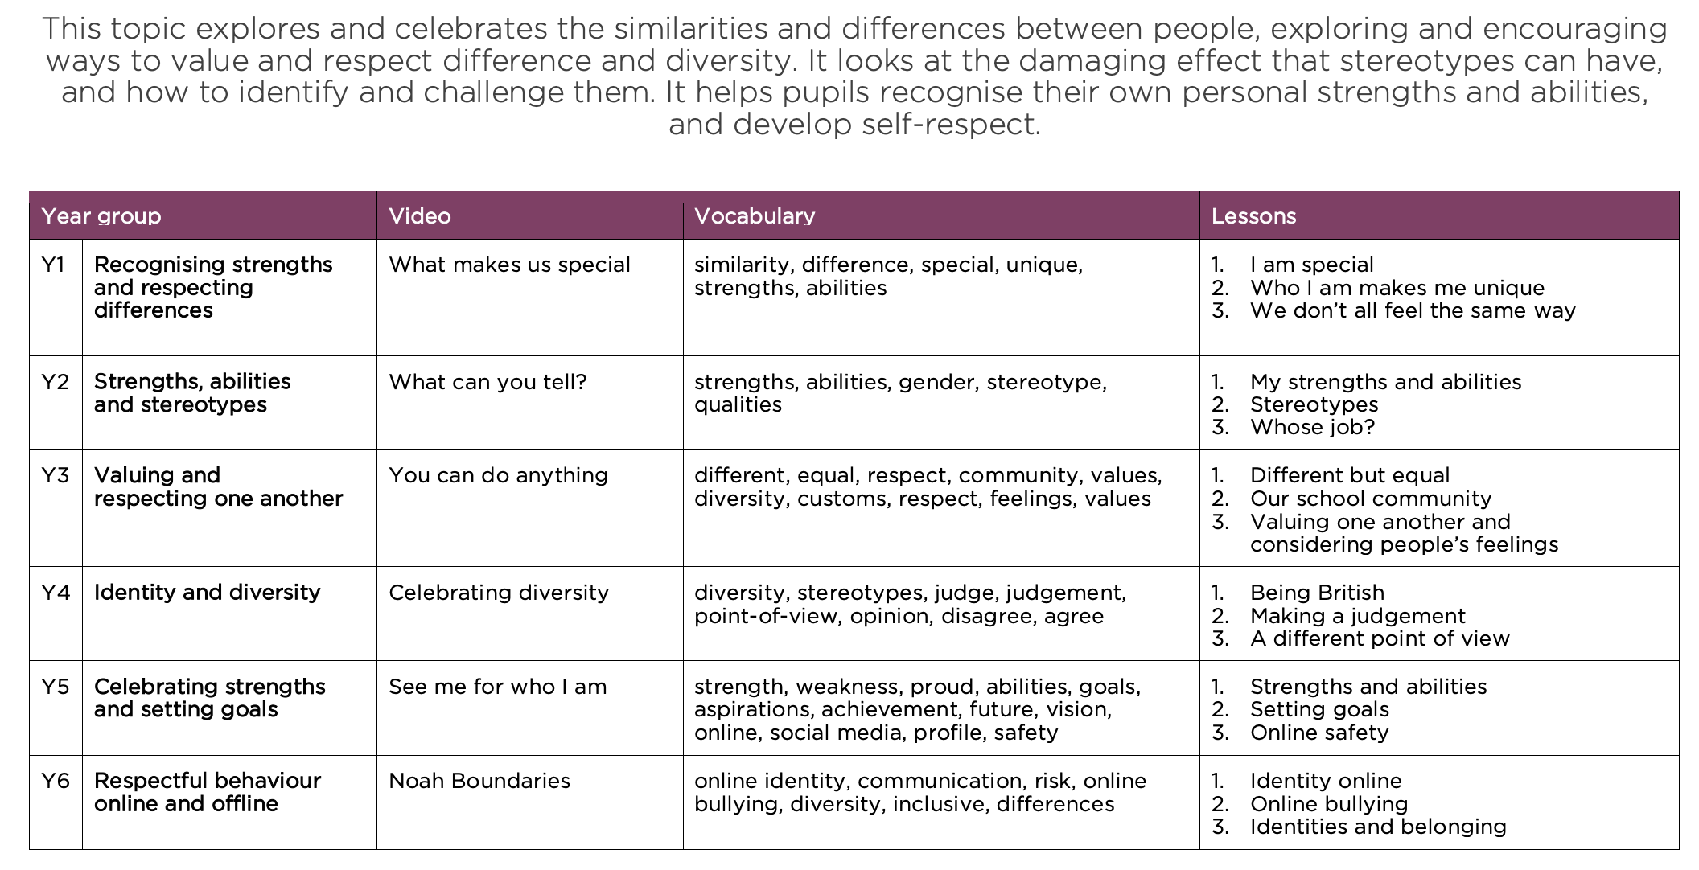

Caring and Responsibility
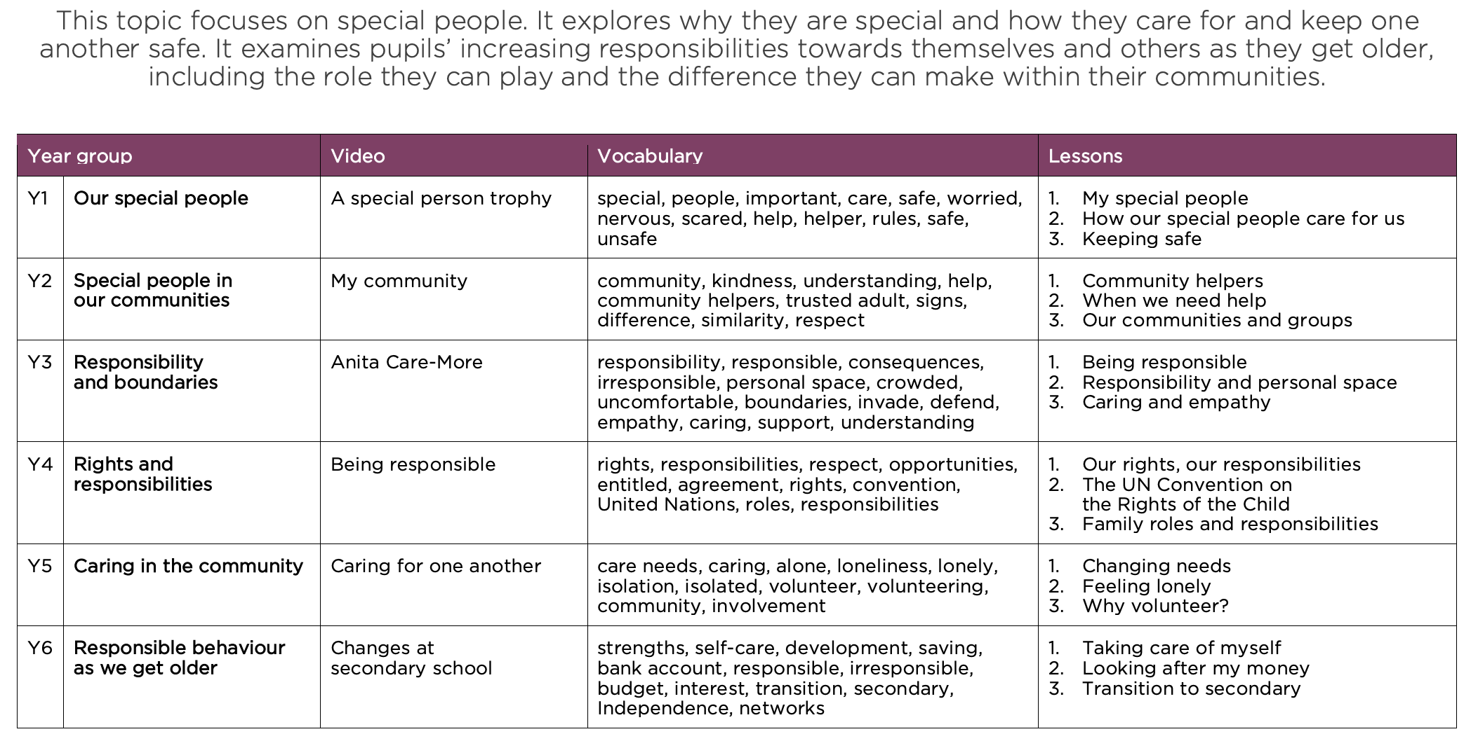

Families and Committed Relationships
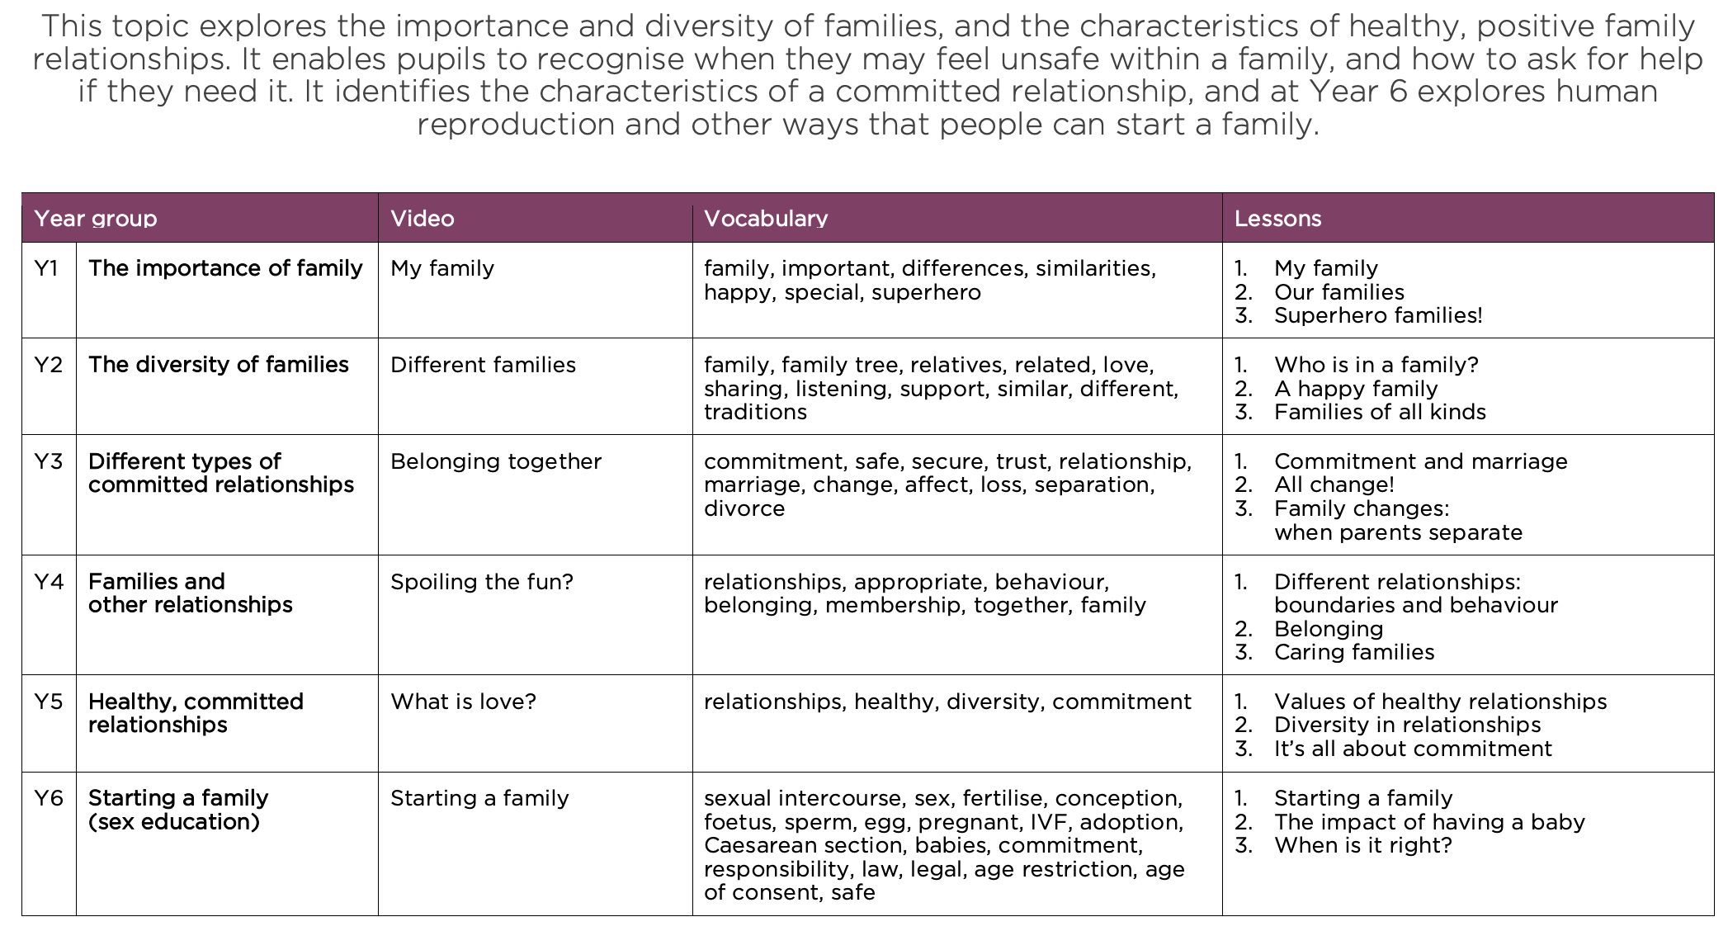

Healthy Body, Healthy Mind
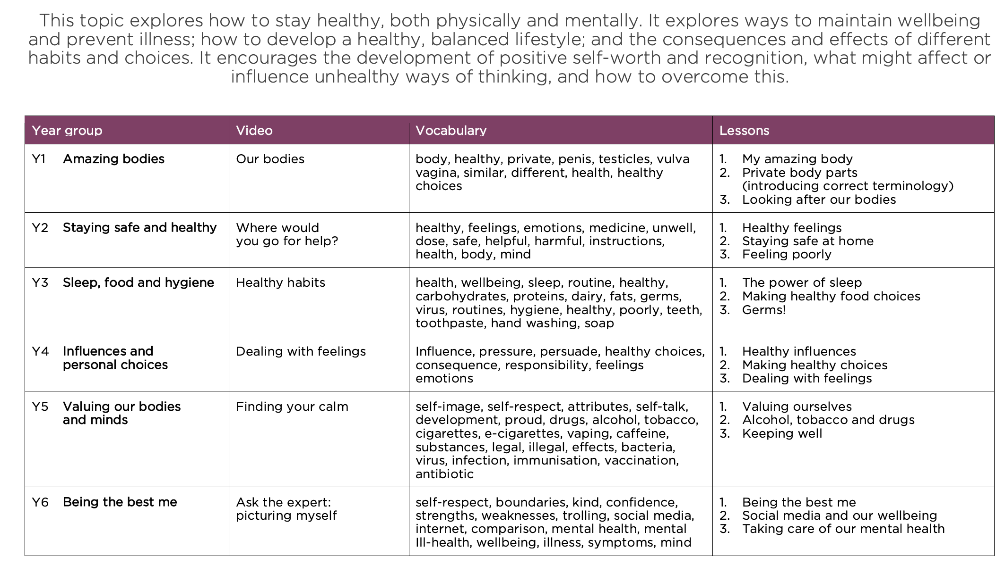

Coping with Change
Year group |  | Video | Vocabulary | Lessons
Y1 | Growing and changing | How I have changed | Growing, adults, babies, change, older, growing up, jobs, future | - Animal babies  - How have we changed?  - A future me
Y2 | Growing up and setting goals | Three generations | Growing, adult, baby, change, timeline, life cycle, likes, dislikes, change, future | - When I am older  - Looking at the changed ahead  - Goals
Y3 | Coping with feelings when things change | When bailey’s dog died | Changes, support, feelings, sad, empathy, sympathy, happy, positive, kind, emotions | - New changes  - Feeling sad and showing empathy  - Happiness
Y4 | Coping with changes to friendships | N/A | Friend, qualities, values, difficulties, compromise, communication, yes, no, boundaries, permission. | - Shared interests.  - Joining in  - Compromising
Y5 | Puberty and hygiene & puberty and emotions | Sweat, soap and showers  Elise explains: Periods | Puberty, hormones, menstruation, eggs, sanitary pads, periods, hygiene, sweat, health, sperm, ovaries, testicles, vagina, penis, emotions, changes, feelings, support, control | - What is puberty?  - Understanding periods.  - Keeping clean as we grow and change  - Puberty  - Puberty and emotions  - Emotional changes: managing well
Y6 | Coping with emotional effects of life changes | Ask the expert: puberty | Body image, reality, pressure, attributes, influence, relationships, emotions, secondary school, future, memories, reflect | - Body image  - Puberty and changing relationships  - Moving on

Appendix 2: By the end of primary school pupils should know
Topic | Pupils should know
Families and people who care about me | - That families are important for children growing up because they can give love, security and stability  - The characteristics of healthy family life, commitment to each other, including in times of difficulty, protection and care for children and other family members, the importance of spending time together and sharing each other’s lives  - That others’ families, either in school or in the wider world, sometimes look different from their family, but that they should respect those differences and know that other children’s families are also characterised by love and care  - That stable, caring relationships, which may be of different types, are at the heart of happy families, and are important for children’s security as they grow up  - That marriage represents a formal and legally recognised commitment of two people to each other which is intended to be lifelong  - How to recognise if family relationships are making them feel unhappy or unsafe, and how to seek help or advice from others if needed
Caring friendships | - How important friendships are in making us feel happy and secure, and how people choose and make friends  - The characteristics of friendships, including mutual respect, truthfulness, trustworthiness, loyalty, kindness, generosity, trust, sharing interests and experiences and support with problems and difficulties  - That healthy friendships are positive and welcoming towards others, and do not make others feel lonely or excluded  - That most friendships have ups and downs, and that these can often be worked through so that the friendship is repaired or even strengthened, and that resorting to violence is never right  - How to recognise who to trust and who not to trust, how to judge when a friendship is making them feel unhappy or uncomfortable, managing conflict, how to manage these situations and how to seek help or advice from others, if needed
Respectful relationships | - The importance of respecting others, even when they are very different from them (for example, physically, in character, personality or backgrounds), or make different choices or have different preferences or beliefs  - Practical steps they can take in a range of different contexts to improve or support respectful relationships  - The conventions of courtesy and manners  - The importance of self-respect and how this links to their own happiness  - That in school and in wider society they can expect to be treated with respect by others, and that in turn they should show due respect to others, including those in positions of authority  - About different types of bullying (including cyberbullying), the impact of bullying, responsibilities of bystanders (primarily reporting bullying to an adult) and how to get help  - What a stereotype is, and how stereotypes can be unfair, negative or destructive  - The importance of permission-seeking and giving in relationships with friends, peers and adults
Online relationships | - That people sometimes behave differently online, including by pretending to be someone they are not  - That the same principles apply to online relationships as to face-to face relationships, including the importance of respect for others online including when we are anonymous  - The rules and principles for keeping safe online, how to recognise risks, harmful content and contact, and how to report them  - How to critically consider their online friendships and sources of information including awareness of the risks associated with people they have never met  - How information and data is shared and used online
Being safe | - What sorts of boundaries are appropriate in friendships with peers and others (including in a digital context)  - About the concept of privacy and the implications of it for both children and adults; including that it is not always right to keep secrets if they relate to being safe  - That each person’s body belongs to them, and the differences between appropriate and inappropriate or unsafe physical, and other, contact  - How to respond safely and appropriately to adults they may encounter (in all contexts, including online) whom they do not know  - How to recognise and report feelings of being unsafe or feeling bad about any adult  - How to ask for advice or help for themselves or others, and to keep trying until they are heard  - How to report concerns or abuse, and the vocabulary and confidence needed to do so  - Where to get advice e.g. family, school and/or other sources
Health and prevention | - About personal hygiene and germs including bacteria, viruses, how they are spread and treated, and the importance of handwashing
Physical health | - Key facts about puberty and the changing adolescent body, particularly from age 9 through to age 11, including physical and emotional changes.  - About menstrual wellbeing including the key facts about the menstrual cycle.
 | The RSHE programme should help pupils know and understand those elements of content set out within the National Curriculum for Science and set out below:
Animals, including humans | Year 1 programme of study  Identify, name, draw and label the basic parts of the human body and say which part of the body is associated with each sense.  Year 2 programme of study  Notice that animals, including humans, have offspring which grow into adults.  Year 5 programme of study  Describe the changes as humans develop to old age (NC Science non-statutory notes & guidance adds: “Pupils should draw a timeline to indicate stages in the growth and development of humans. They should learn about the changes experienced in puberty. Pupils could work scientifically by researching gestation periods of other animals & comparing them with humans…”)
Living things and their habitats | Year 5 programme of study  Describe the differences in the life cycles of a mammal, an amphibian, an insect and a bird.  Describe the life process of reproduction in some plants and animals. (NC Science non-statutory notes & guidance adds: “Pupils should find out about different types of reproduction, including sexual and asexual reproduction in plants, and sexual reproduction in animals.”)  Year 6 programme of study  Recognise that living things produce offspring of the same kind, but normally offspring vary and are not identical to their parents.

Appendix 3: Parent form: withdrawal from sex education within RSE

To be completed by parents
Name of child |  | Class
Name of parent |  | Date
Reason for withdrawing from sex education within relationships and sex education
Any other information you would like the school to consider
Parent signature

To be completed by the school
Agreed actions from discussion with parents

