KEY STAFF
 | 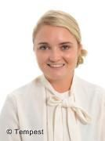
Becky Hayter  Head Teacher | Jennifer Lawton  Deputy Headteacher
Katie Fairclough  Reception teacher | Debbie Cruse  Reception teaching assistant
Jo Bice  Reception teaching assistant | Joanne Thornton  Special Educational Needs Lead
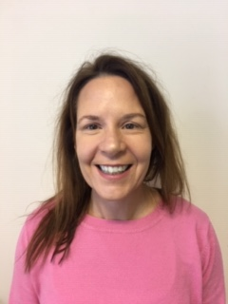
Noreen Booth  Office Manager | Suzie Freeman  Office administrator

