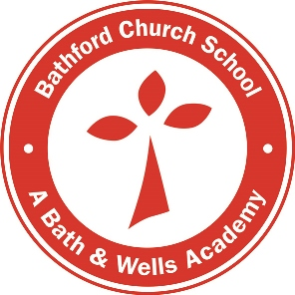
Curriculum map: termly topics 2020-2021

 | Term 1 | 2 | 3 | 4 | 5 | 6
Theme | Identity & Diversity |  | Social Justice & Equity |  | Sustainable Development
R | We Are All Special |  | Our World |  | Spirit of Adventure
Y1 | Our Super Selves |  | Rewind |  | Into the Enchanted Forest
Y2 | Amazing Animals |  | Chocolate |  | I love London!
Y3 | Mexico |  | Romans |  | Stone Age
Y4 | Picture This! |  | Ancient Egyptians |  | Anglo Saxons and Vikings
Y5 | Victorians |  | Ancient Greece |  | Growing and making
Y6 | Wonder |  | Holes |  | Marvellous Maya

Our curriculum will evolve over the year. The principle of topic-based, cross-curricular, creative and responsive learning underpins our approach to teaching and learning and therefore may be subject to change over the year and are not ‘set in stone’.

