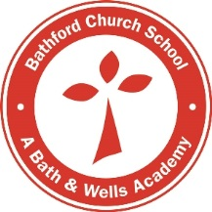
Bathford Church School
Advertising Policy 2020-21

It is our general policy not to circulate or display any solicitation or advertisement for products, services or activities. This is for the protection of the school and its pupils.
Communications related to St Swithun’s Church and FOBS (Friends of Bathford School), as well as organisations who have freely given their time to school activities, are exempted from this policy due to the direct nature of their involvement in/with the school. This exemption also extends to sponsorship of fundraising initiatives organised by FOBS by parties external to the school.
There may be some circumstances where outside providers are referred to in school correspondences if the school has worked with the providers.

