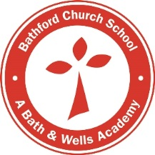
Bathford Church School
Breakfast and After School Clubs
Booking Request

Child’s name
Class

Breakfast Club (7.45am – 9am)
 | Monday | Tuesday | Wednesday | Thursday | Friday
Sessions required

After School Club (3.15pm – 6pm)
 | Monday | Tuesday | Wednesday | Thursday | Friday
Sessions required |  |  |  |  | Currently not available

Parent
Mobile number
Date

Office Use only:
Date added to ScholarPack register:
T:\Teachers_Only_FROM_OLD_SERVER\Breakfast And After School Club\2020 - 2021 WRAPAROUND CARE\Booking request form

